Abram Denzlinger
November 1, 2025
CSD310 - 2.3 Assignment - Data Models

Entity Relationship Diagram (ERD)

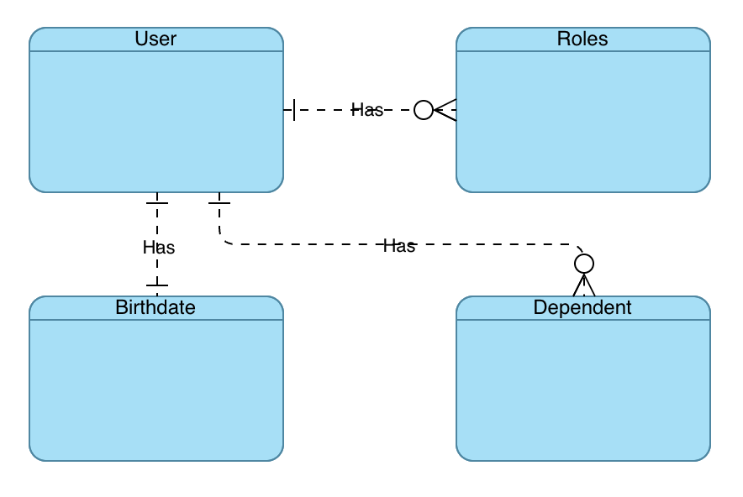

NoSQL Data Structure

{
user_id: “1234”,
first_name: “Stewart”,
last_name: “McDonald”,
birthdate: “01/02/1994”
roles: [
{
field_1: “role info”,
field_2: “role info”
},
{
field_1: “role info”,
field_2: “role info”
}
]
dependents: [
{
field_1: “dependent info”,
field_2: “dependent info”
}
{
field_1: “dependent info”,
field_2: “dependent info”
}
]
}

